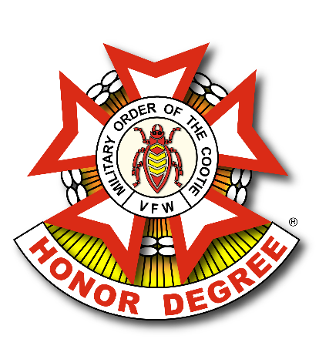
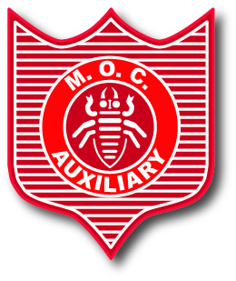
MEMORIAL SERVICE
GRAND OF (State Name) SCRATCH

GRAND COMMANDER
“WELCOME ALL! WE ARE HERE TO COMMEMORATE, THE MEMORY OF OUR DEPARTED COMRADES, COOTIES, SISTERS AND BROTHERS.
THE MILITARY ORDER OF THE COOTIE IS NOT SOLELY A FUN ORGANIZATION.
SERIOUS THOUGHT IS GIVEN TO OUR DEPARTED, AND IT IS TO THESE THAT WE PAY OUR RESPECTS AT THIS TIME.
I RESPECTFULLY REQUEST THAT THERE BE NO SMOKING AND TALKING DURING THIS CEREMONY.
SILENCE IS STRICTLY ESSENTIAL WHILE THE SERVICE IS BEING HELD.”

GRAND COMMANDER (SPEAKING TO PROVOST MARSHAL)
“PROVOST MARSHAL, IS ALL PREPARED TO PROCEED WITH THE CEREMONY?”
PROVOST MARSHAL (SPEAKING TO GRAND COMMANDER)
“ALL HAS BEEN PREPARED.”
GRAND COMMANDER (SPEAKING TO ADJUTANT)
“ADJUTANT, PLEASE CALL THE ROLL OF PUP TENTS.”

ADJUTANT
(ADJUTANT MOVES TO THE CENTER OF AREA, IN FRONT OF FIELD OF POPPIES, FACES THE AUDIENCE).
(ADJUTANT THEN CALLS THE ROLL OF PUP TENTS BY NUMBER ONLY)
THEN STATES: “ALL ACCOUNTED FOR EXCEPT PUP TENT NUMBER (S) _________ “
GRAND PRESIDENT (SPEAKING TO SECRETARY):
“SECRETARY PLEASE CALL THE ROLL.”
SECRETARY
(SECRETARY MOVES TO THE SIDE OF THE ADJUTANT).
SECRETARY CALLS THE ROLL OF AUXILIARIES BY NUMBER ONLY) THEN STATES: “ALL ACCOUNTED FOR EXCEPT FOR AUXILIARY NUMBER (S)______”
GRAND COMMANDER
“ADJUTANT, SECRETARY, YOU BOTH MAY RESUME YOUR STATIONS.”
(ADJUTANT AND SECRETARY MOVE OFF TOGETHER).
GRAND COMMANDER
“CHAPLAINS, PLEASE CONTINUE WITH THE CEREMONY.”
MOC AND MOCA CHAPLAIN
(POSITION THEMSELVES TO THE RIGHT AND LEFT SIDE OF THE FIELD OF POPPIES, FACING THE AUDIENCE).
MOC CHAPLAIN
“AS THE ROLL WAS CALLED SOME COOTIES, BROTHERS AND SISTERS FAILED TO ANSWER. THEY WERE ANSWERING A CALL IN A MUCH HIGHER PLACE.”

MOCA CHAPLAIN
“AT THIS TIME, TO COMMEMORATE THE MEMORY OF THESE DEPARTED COOTIES, BROTHERS AND SISTERS, WE ASK THE SEAM SQUIRRELS AND PRESIDENTS OF THEIR PUP TENTS AND AUXILIARIES TO PLACE A CROSS IN THE FIELD OF POPPIES AS THEIR NAME IS CALLED.”

MOC AND MOCA CHAPLAIN
(START ROLL CALL OF DECEASED, BEGINNING WITH THE LOWEST NUMBERED PUP TENT/AUXILIARY, ALTERNATING MOC AND MOCA. (PAUSE BETWEEN NAMES SO THAT THE BELL FOR EACH NAME CAN BE SOUNDED IF AVAILABLE).
(AS THE NAMES ARE CALLED, THE SEAM SQUIRREL, PRESIDENT OR REPRESENTATIVE, WILL MOVE FORWARD, PLACE A CROSS IN THE FIELD OF POPPLIES, THEN TAKE TWO STEPS BACK. RENDER A SALUTE AND RETURN TO STATION).
PLAY MUSIC AFTER THE LAST CROSS IS PLACED, i.e. AMAZING GRACE (BAGPIPES).

MOC CHAPLAIN RECITES THE FOLLOWING MEMORIAL SERVICE PRAYER.
“OUR HEAVENLY FATHER, WE ASK THAT YOU BLESS THE COMRADES, BROTHERS AND SISTERS WE ARE HONORING TODAY.
WHEN THE CALL OF OUR COUNTRY WAS HEARD, THESE COMRADES ANSWERED. WHEN THE COMRADES RETURNED, THE AUXILIARY SUPPORTED THEM IN SOMETIMES TRYING TIMES.
SELF WAS FORGOTTEN IN THE CAUSE OF THE GREATER GOOD.
BRAVELY THE COMRADES MARCHED AWAY WITH AN ABIDING FAITH IN THEIR GOD, THEIR COUNTRY, AND THEIR FLAG.
THE RED OF OUR COUNTRY’S FLAG WAS MADE REDDER STILL BY THEIR HEROISM; THE WHITE MORE STAINLESSLY PURE BY THE MOTIVES WHICH IMPELLED THEM; AND IN THE STARRY FIELD OF OUR NATION’S GLORIOUS BANNER THE BLUE HAS BEEN GLORIFIED BY THE SERVICE THEY HAVE GIVEN FOR AMERICAN IDEALS.
AS COMRADE AFTER COMRADE DEPARTS, WE MARCH ON WITH OUR RANKS GROWING THINNER.
GOD OF BATTLES, FATHER OF ALL, AMID THIS, WE SEE YOUR HAND.
WE ASK YOU TO LOOK IN MERCY ON ALL HERE ASSEMBLED, BOTH COMRADES AND AUXILIARY MEMBERS, WITH YOUR OWN TENDERNESS.
HEAVENLY FATHER, BLESS OUR COUNTRY WITH FREEDOM, PEACE, AND RIGHTEOUSNESS AND THROUGH YOUR SOVEREIGN AND HOLY SPIRIT’S FAVOR, MAY WE ALL MEET AT LAST BEFORE YOUR THRONE OF GRACE IN HEAVEN.
MAY EVERYONE PRAISE YOUR GREAT NAME FOREVER AND EVER!
AMEN.

GRAND COMMANDER
(NODS TO THE RIFLE TEAM AND THEY FIRE THEIR WEAPONS IN VOLLEY)
(AFTER THE RIFLE TEAM VOLLEY THE GRAND COMMANDER SAYS…)
“ATTENTION, PRESENT ARMS!”
(AFTER THE GRAND COMMANDER SAYS PRESENT ARMS, TAPS WILL BE PLAYED)
(AFTER TAPS THE GRAND COMMANDR SAYS…):
“THIS CONCLUDES OUR CEREMONY”.

